Resident Wildfire Mitigation Grant Application

The City of Castle Pines supports the community by providing financial resources to eligible homeowner groups to conduct hazardous fuels and wildfire mitigation reduction projects to protect the community and their property from wildfire hazards.

Please email this form and any supporting documentation to Makenna Shaw, Assistant to the City Manager, Makenna.Shaw@castlepinesco.gov no later than May 14, 2023 at 11:59 pm.

Applicant Information

Resident Name: | Click or tap here to enter text.
Address: | Click or tap here to enter text.
Phone: | Click or tap here to enter text.
Email: | Click or tap here to enter text.
Property Owner Name:  (If different from above) | Click or tap here to enter text.
Property Owner Email:  (If different from above) | Click or tap here to enter text.

Eligibility

I am the owner of this property, or have permission from the owner to conduct this project:
☐ Yes ☐ No
Will any planted materials be removed?
☐ Yes ☐ No
If yes, will any plants replace those removed?
☐ Yes ☐ No ☐ N/A
If yes, are the plants on the approved SMFR Wildfire Resistant Plant List?
☐ Yes ☐ No ☐ N/A
Will any wood materials, tree limbs, shrubs, or brush be removed from the property?
☐ Yes ☐ No
If yes, have you determined the method of disposal of the collected materials? You will be asked to expand on this in the Project Summary section. Please see our resources page for suggest means of disposal.
☐ Yes ☐ No ☐ N/A
☐This project is not in violation of my Homeowner Associations covenants, and I have followed the appropriate processes for approvable from all applicable parties (HOA, etc.), if required.

Risk Assessment

South Metro Fire Rescue uses a quick evidence-based assessment to determine the level of wildfire risk for your home. Please complete the following questions by selecting the answer that best represents your property for each item.

Location of woodpiles and combustibles: Combustible materials that are within Zone 1 (0-30 feet) of the defensible space zones of your home present an additional ignition vulnerability. Any material that is combustible is considered during the assessment period. Common examples of combustible materials include wicker patio furniture, ornamental decorations, firewood, kindling, bark mulch.
☐ None or > 30 ft from structure
☐ 10-30 feet from structure
☐ < 10 feet from structure
VEGETATION & TOPOGRAPHY - The angle of hill slopes and the types of vegetation around your home is important when defending your home. Various free "slope finder" phone apps can be downloaded to help determine your home's slope.
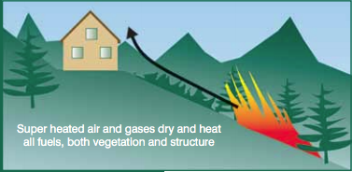
Slope: Generally speaking, wildfire behavior is driven by three factors: weather, fuels and topography. While the “Distance to Dangerous Topography” category characterizes how close a home is to a high risk topographic feature, this Slope category characterizes the average overall slope throughout the area where the home is situated. Homes situated on the steepest slopes (>45%) were given the highest rating.

☐ Less than 20%
☐ Between 20% and 45%
☐ Greater than 45%

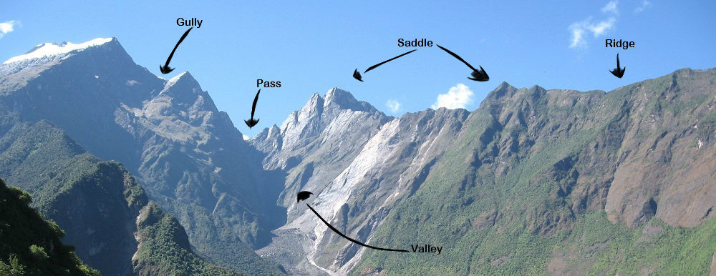
Distance to dangerous topography: The proximity of a home to certain topographic features may significantly impact that home’s survivability during a wildfire. Such features include over-steepened slopes, chimneys, drainages, gullies, narrow canyons, ridges, etc. These features are areas where wildfires can move quickly, increase in wildfire intensity and impact wildfire behavior. This is as an approximate measure of the proximity of your home to any such topographic feature.

The picture is an exaggerated example to help define terms.

☐ More than 150 feet
☐ 50-150 feet
☐ Less than 50 feet
Predominant background fuel type in neighborhood: The fuel type and density directly surrounding a home can affect the fire behavior in the particular area. Given varying weather conditions, grassy open meadows tend to be conducive to fast moving, yet low intensity fire behavior, where as fire in a heavily forested environments can be much more intense.
☐ Light (grasses, forbs, tundra)
☐ Moderate (light brush, small tree)
☐ Heavy (dense brush or timber, down and dead fuel)
Defensible space (CSFS 6.302 Standards)
To prepare your home for the possibility of wild fire, it is critical that you create defensible space within the Home Ignition Zone. According to the Colorado State Forest Service, defensible space is “the natural and landscaped area around a home or other structure that has been modified to reduce fire hazard. Defensible space gives your home a fighting chance against an approaching wildfire.” This is an approximation of the amount of adequate defensible space surrounding all structures on your property.
☐ More than 150 feet
☐ 30-150 feet
☐ 10-30 feet
☐ Less than 10 feet

Project Funding

Total project amount: | $Click or tap here to enter text.
Amount requested: | $Click or tap here to enter text.
Would you accept an award of less than the amount requested if funding is not available for the full amount?
☐ Yes ☐ No

Project Budget
A 50% minimum match is required. However, projects with a higher match will score higher in the budget category when applications are evaluated.

 | Grant Share  ($ requested) | Match ($) | Total
Volunteer / Labor: | Click or tap here to enter text. | Click or tap here to enter text. | Click or tap here to enter text.
Supplies / Materials: | Click or tap here to enter text. | Click or tap here to enter text. | Click or tap here to enter text.
Contractual Services: | Click or tap here to enter text. | Click or tap here to enter text. | Click or tap here to enter text.
Total Project Budget: | Click or tap here to enter text. | Click or tap here to enter text. | Click or tap here to enter text.
Project Match (%): | Click or tap here to enter text. | Click or tap here to enter text. | 100%
Please be sure the total grant share amount matches the requested amount above, and the total project amount above matches the total project budget in green.

Project Summary

Project information:  Please describe the overall project, including the process for determining the need for mitigation, the aspects of the project, and who will be completing this project (I.e.: contractors, yourself, etc). | Click or tap here to enter text.
Project area description and current conditions:  Please include how this project area would be considered a wildfire risk. | Click or tap here to enter text.
Description of method of any material disposal:  Please visit our grant resources page for information on slash mulch and program dates. | Click or tap here to enter text.
How will this project benefit the City of Castle Pines community? | Click or tap here to enter text.
Schedule of key project dates:  Please include the dates that will help determine if your project is on track throughout the project, as well as the anticipated final report submission/request for reimbursement) | Click or tap here to enter text.

Authorization

☐ I certify that I am the owner of the entire property of which this project will be conducted or have received the appropriate approvals from the property owner.

☐ I certify that this project is not in violation of my Homeowner Associations covenants, and I have followed the appropriate processes for Homeowner Association approvable, if applicable.

☐ I confirm that this project will be completed in 2023, and the final report and corresponding receipts will be submitted no later than December 31, 2023.

Submitted by | Click or tap here to enter text.
Date | Click or tap here to enter text.

